EXP 18

clc;
clear;
close all;

% Eye Diagram Analysis under Inter-Symbol Interference (ISI)
% No Communications Toolbox required

% Step 1: Parameters
N = 1000; % Number of bits
sps = 20; % Samples per symbol SNR_dB = 20; % Signal-to-noise ratio

% Step 2: Generate Random Binary Data data = randi([0 1], 1, N);

% Step 3: BPSK Modulation symbols = 2*data - 1;

% Step 4: Upsampling tx = zeros(1, N*sps);
tx(1:sps:end) = symbols;

% Step 5: Create Channel with ISI
% Current symbol is affected by neighboring symbols h = [0.25 1 0.45];

% Apply channel response rx_isi = conv(tx, h, 'same');

% Step 6: Add AWGN
signal_power = mean(rx_isi.^2);
noise_power = signal_power / (10^(SNR_dB/10)); rx = rx_isi + sqrt(noise_power)*randn(size(rx_isi));

% Step 7: Plot Transmitted Signal figure;
plot((0:10*sps-1)/sps, tx(1:10*sps), 'b'); grid on;
xlabel('Time (Symbol Periods)'); ylabel('Amplitude');
title('Transmitted BPSK Signal');

% Step 8: Eye Diagram without ISI figure;
hold on;

for k = 1:2:N-2
idx = (k-1)*sps + 1;
if idx + 2*sps - 1 <= length(tx) segment = tx(idx:idx+2*sps-1);
plot((0:2*sps-1)/sps, segment, 'b'); end
end

grid on;
xlabel('Time (Symbol Periods)'); ylabel('Amplitude');
title('Eye Diagram without ISI'); xlim([0 2]);
hold off;

% Step 9: Eye Diagram with ISI and Noise figure;
hold on;

for k = 1:2:N-2
idx = (k-1)*sps + 1;
if idx + 2*sps - 1 <= length(rx) segment = rx(idx:idx+2*sps-1);

plot((0:2*sps-1)/sps, segment, 'r'); end
end

grid on;
xlabel('Time (Symbol Periods)'); ylabel('Amplitude');
title('Eye Diagram with ISI and AWGN'); xlim([0 2]);
hold off;

% Step 10: Evaluate Eye Diagram Parameters
% Sample at symbol centers
sample_idx = 1:sps:length(rx); samples = rx(sample_idx);

% Estimate eye height from symbol-center samples level1 = samples(data == 0);
level2 = samples(data == 1);

eye_height = mean(level2) - mean(level1); noise_spread = std(samples);

% Calculate threshold detection and BER

detected_bits = samples > 0;
BER = sum(detected_bits ~= data)/N;

% Display Results
fprintf('\n--- Eye Diagram Parameters ---\n'); fprintf('Eye Height = %.4f\n', eye_height);
fprintf('Sample Standard Deviation = %.4f\n', noise_spread); fprintf('Bit Error Rate (BER) = %.4f\n', BER);

% Step 11: Plot Received Signal figure;
plot((0:10*sps-1)/sps, rx(1:10*sps), 'r'); grid on;
xlabel('Time (Symbol Periods)'); ylabel('Amplitude');

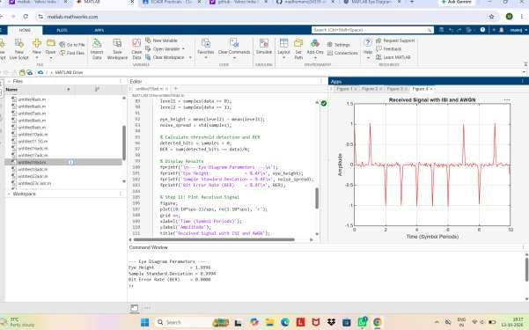
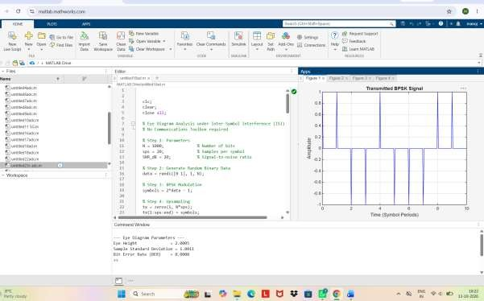
title('Received Signal with ISI and AWGN');

